Frequently asked questions
How can I find out which school my child has been offered?
If you applied online you will need to log into your eAdmissions account at www.eadmissions.org.uk. You also need to use your eAdmissions account to accept the place your child has been offered.
The outcome of your application will be published after 7 pm on 1 March 2023. You will receive an email or text advising you to log into your eAdmissions account.
How can I find out my child’s waiting list positions?
If you email the Admission Service at esas@enfield.gov.uk giving your child’s application reference number or their name and date of birth we can email information about your child’s waiting list position for most schools in Enfield. You will need to contact the following schools directly, though, for their waiting list information:
St Anne’s Catholic High School for Girls
Please note The Latymer School has written to the parents of the children who are on their continuing interest list to let them have their child’s position as at 1 March 2023.
For schools outside of Enfield, you will need to contact the Borough in which the school is situated or the school directly to find out this information.
How often will my child’s waiting list position change?
There will not be any changes to the waiting lists until after 17 March 2023 at the earliest. After this time changes can happen every couple of weeks.
Where can I find a list of schools with vacancies that I can apply for now?
There is a list of schools with vacancies on the website at this link https://www.enfield.gov.uk/__data/assets/pdf_file/0020/33806/Secondary-transfer-vacancies-2023-Education.pdf. Please note that some schools may only have one of two places available. The admissions criteria will be used to decide which children are offered the places. The list of schools with vacancies is likely to change after 17 March 2023.
I have changed my mind, can I now apply for a different school for my child to attend?
You can apply for an alternative school by completing a ST2 form. This can be downloaded from https://www.enfield.gov.uk/__data/assets/pdf_file/0028/33796/Transfer-to-secondary-ST2-form-2023-Education.pdf and once completed, emailed to esas@enfield.gov.uk. If you are unable to download a ST2 form you can email your request but please make sure you include your child’s name, date of birth and list clearly the schools you wish to apply for in priority order.
How do I apply for a school in another borough?
You can apply using the ST2 form which can be downloaded from this link https://www.enfield.gov.uk/__data/assets/pdf_file/0028/33796/Transfer-to-secondary-ST2-form-2023-Education.pdf. Once completed, the form can be emailed to esas@enfield.gov.uk.
How can I accept the place for my child?
You accept the place offered to your child by logging into your eAdmissions account at www.eadmissions.org.uk
I have forgotten my password for eAdmissions, how can I find this?
If you go to www.eadmissions.org.uk, the Frequently Asked Questions section at the top of the first page has a help for parents section.

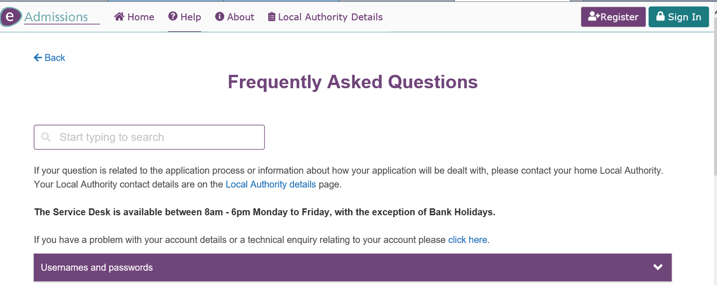

I have moved. How do I let you have my new address?
You will need to send an email letting us have either your child’s reference number or their name and date of birth. You will need to send through proof that you are living in the new property and confirmation that you have left the previous address. The proofs can be photographed and sent to us. The email address is esas@enfield.gov.uk. If your child is on the waiting list for a higher preference school the position will not change until after 17 March 2023.
I have moved and I now live nearer to the school I wanted. When will my waiting list position change?
Your child’s waiting list position may change but you will not be able to find out your child’s revised waiting list position after 17 March 2023.
Will my child still be considered for my higher preference schools if I accept the place you have offered?
You can accept the place your child has been offered and this will not affect their waiting list position for any of the other higher preference schools you have requested. It is important to understand that if you decline the place offered it will not improve your child’s waiting list position for any of the other schools requested.
I haven’t applied for a school place and my child is due to start secondary school in the Autumn Term 2023, how can I apply?
You can make your application online at www.eadmissions.org.uk. You will need to send through documentation to confirm your address. This can be emailed to esas@enfield.gov.uk. Please make an application as soon as possible.
How can I lodge an appeal for a school?
If the school is an Enfield community school information about appeals is on the council website at this link - https://new.enfield.gov.uk/services/children-and-education/school-admissions-and-information/admissions-appeals/
If the school is their own admission authority details will be on the school’s website. If the school is outside of Enfield you should check the position with the relevant local authority, again details will be on their website.
Where can I find information about the admission criteria for schools in Enfield?
Information about the admissions criteria for all schools in Enfield is published in the secondary admissions booklet which can be viewed online Guide to Secondary Schools – August 2022 (intuitive-design.co.uk)
Schools which are their own admission authority will also publish their information on their own websites.

